**Experiment: 10**

**Student Name: Rishav Kumar UID: 22MCC20039**

**Branch: MCA - CCD Section/Group: 22MCD1 / Grp A**

**Semester: II Date of Performance:11th May 2023**

**Subject Name: Software Testing Subject Code: 22CAH-685**

**Q. What is JQL?**

JQL stands for "Jira Query Language," and it is a query language used to search for

issues in Jira, which is a popular project and issue tracking tool. JQL provides a

simple and flexible way to search for issues by specifying search criteria based on

various fields such as status, assignee, priority, issue type, and more.

**Q. Structure of JQL query**

<field><operator><value> Keyword <field><operator><value

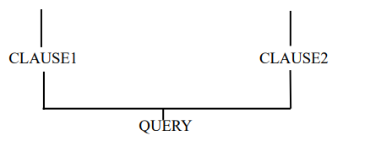

**Example:** Project = SOF AND issuetype= bug.

Here SOF is the field that is the search criteria to filter the issue and to assign value

of the field operator is used. Some of the operators are =, != , is not, is, not in ,in,was , was not, was in, was not in , changed. Keyword are logical operators like

AND and OR.

**Q. Write a Jira Query**

project =RK AND issuetype = Epic AND status in (Done, "To Do") AND

assignee in (EMPTY) AND reporter in (712020:eca487b2-f9cd-4118-8351-

63f113e0e379) AND created >= -30d AND due >= 2023-05-10 AND due <= 2023-

05-11-AND "Issue color"=grey

**Steps to perform advanced issue search using JQL**

* Login to your Jira account
* Click on the ‘Filters’ or click on the search bar located on the top right corner

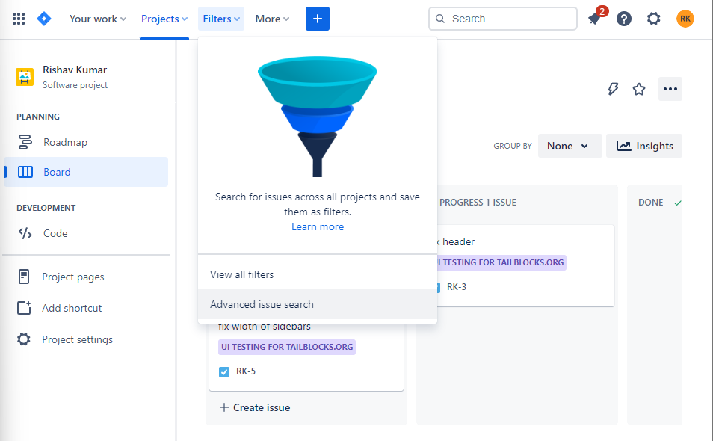

* Click on advanced issue search
* In the search bar if the filtering is basic click on ***the switch to JQL*** option to the right of the search button.

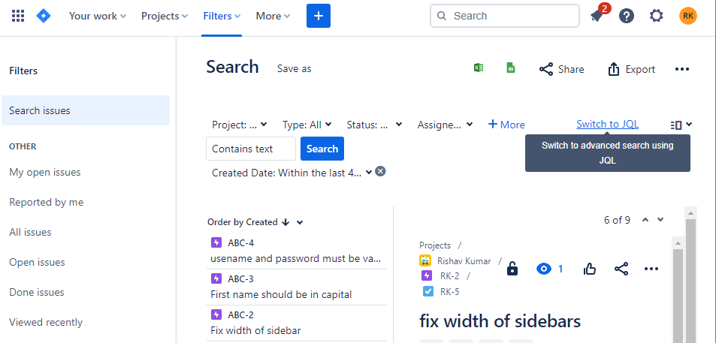

* Enter your JQL query. As you type, Jira will offer a list of autocomplete suggestions based on the context of your query.

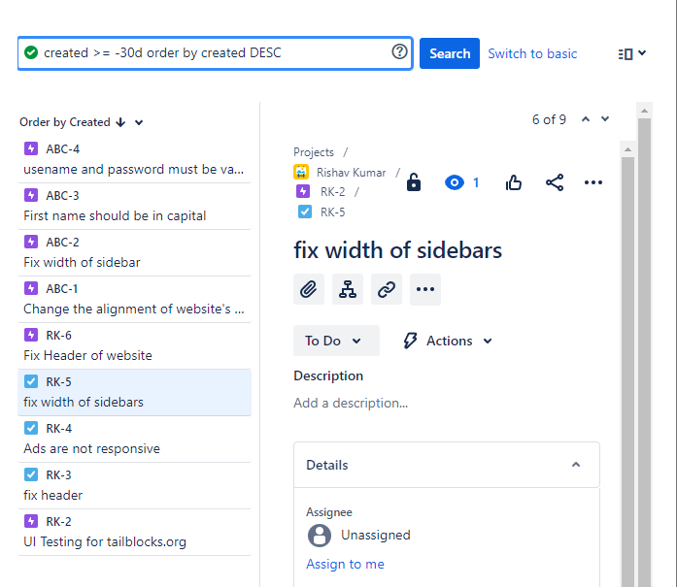

* Now click search button and the issue based on the given criteria will be displayed.